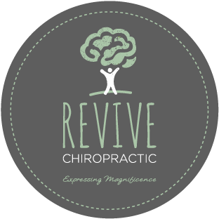
Tel: (03) 9471 1000
Fax: (03) 9471 1099
658 High St, Reservoir, VIC, 3073
E-mail: info@revivechiropractic.com.au
www.revivechiropractic.com.au

Informed Consent to Chiropractic Care
When a person seeks chiropractic care, it is essential for both the individual and the chiropractor to be working towards the same objective.

Chiropractic care has one goal, to correct vertebral subluxations. It is important that each person understand both the objective and the method that will be used to attain it. This will prevent any confusion or disappointment.

Vertebral Subluxation: A misalignment of one or more of the 24 vertebra in the spinal column which causes alteration of the nerve function and interference to the transmission of mental impulses, resulting in a decrease in the body’s innate ability to express its maximum health potential.

Adjustment: An adjustment is a specific application of forces to facilitate the body’s correction of a vertebral subluxation. Our method of correction is by specific adjustments of the neurospinal system.

Health: A state of optimal physical, mental, and social wellbeing, not merely the absence of symptoms.

I understand that my care at this office will be focused on the detection and correction of vertebral subluxations. I hereby request and consent to the performance of chiropractic adjustments and assessments. Understanding that everybody has a different potential for wellness thus, the maximal results I will receive in this office cannot be predicted or guaranteed.

Chiropractic care is considered to be one of the safest and most effective forms of care. I understand and am informed that, unlike many other health care professions, the risks associated in receiving chiropractic care are extremely minimal. In recent years there have been rare incidents of injury to the vertebral artery during the course of care by medical doctors, physiotherapists and chiropractors. To put this in perspective, the risk of stroke in the general population is 0.00057%. The risk of stroke after a chiropractic adjustment is 0.00025%. The risk of death from taking an aspirin and/or other anti-inflammatory drugs is 0.04%.

It is not our goal or intention to diagnose, treat or attempt to cure any physical, mental, emotional symptoms. Our expertise is in health, wellness, healing and human physiology. However, if during the course of chiropractic care, we encounter unusual findings, we will bring these to your attention. If you desire advice, diagnosis or treatment for those findings, we will recommend that you seek the services of a health care provider who specializes in that area. Please discuss care alternatives with attending chiropractor.

Our primary goal is to release life in the body, through the detection and correction of vertebral subluxations.

At this office, the privacy of your personal information is an essential part of our office providing you with quality care. We are committed to collecting, using and disclosing your personal information responsibly. Our office has a privacy policy that complies with federal law, which you may view at any time by asking our staff.

I, _______________________ have read and fully understand the above statements.
(PRINT NAME)
I have also had an opportunity to ask questions about its content. I therefore accept chiropractic assessments and care on this basis. I intend this consent form to cover the entire course of my care in this office with Dr Vanessa Fullard, Dr Bernie Haberman or other attending chiropractor.

_______________________________________________________________________________________
(SIGNATURE) (DATE) (WITNESS)

(Information released from: The National Center for Health Statistics USA, 1993 and A Risk Assessment for Cervical Manipulation vs. Non-Steroid Anti-inflammatory Drugs for the Treatment of Neck Pain, JMPT, Oct. 1995)

